**Ivancich Stefano 1227846**

**Neural Network and deep learning course 2020/21**

**Homework 3**

1. **Introduction**

In this homework we have to implement and test neural network models for solving reinforcement learning problems.

The basic tasks require to implement some extensions to the code that you have seen in the Lab, that is trying to improve the learning convergence (learn to obtain maximal score with fewer epochs).

The second task require to train and test the learning agent using the screen pixels as state.

The final tasks consist of train and test the learning agent on a different environment, we choose MountainCar-v0.

The ***CartPole-v1* environment** consist of a pole that is attached by an un-actuated joint to a cart, which moves along a frictionless track. The system is controlled by applying a force of +1 or -1 to the cart. The pendulum starts upright, and the goal is to prevent it from falling over by increasing and reducing the cart's velocity. A reward of +1 is provided for every timestep that the pole remains upright. The episode ends when the pole is more than 15 degrees from vertical, or the cart moves more than 2.4 units from the center.

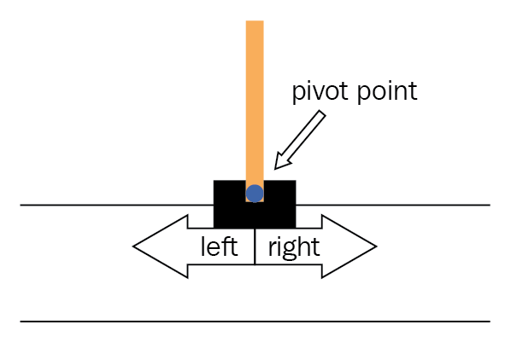

**State space vector:**

* 0: Cart Position
* 1: Cart Velocity
* 2: Pole Angle
* 3: Pole Velocity At Tip

**Actions space vector:**

* 0: Push cart to the left
* 1: Push cart to the right

Note: The amount the velocity is reduced or increased is not fixed as it depends on the angle the pole is pointing. This is because the center of gravity of the pole increases the amount of energy needed to move the cart underneath it

**Reward:** Reward is 1 for every step taken, including the termination step. The threshold is 475.

….. we added

# We apply a (linear) penalty when the cart is far from center

pos_weight = 1

reward = reward - pos_weight * np.abs(state[0])

**Starting State:** All observations are assigned a uniform random value between ±0.05.

**Episode Termination:**

* Pole Angle is more than
* Cart Position is more than (center of the cart reaches the edge of the display)
* Episode length is greater than 500

1. **Speeding up learning Convergence**

…..

In this case we will use the Huber loss as loss function (https://pytorch.org/docs/stable/generated/torch.nn.SmoothL1Loss.html). The Huber loss uses a squared term if the absolute element-wise error falls below beta and an L1 term otherwise. It is less sensitive to outliers than the MSELoss and in some cases prevents exploding gradients.

To overcome the exploration-exploitation dilemma, we will be using the epsilon-greedy approach to slowly decrease the randomization factor overtime. This will ensure that our agent will have a wide variety of state-action training samples and in the later part of the training, it will allow the agent to follow it’s own “trained strategy” as opposed to random actions.

Technically, in the code, we will be using a temperature term to smooth the probability of actions, and epsilon to decide between whether to take a random action or the predicted action output from the policy.

gamma = 0.97 # gamma parameter for the long term reward

replay_memory_capacity = 10000 # Replay memory capacity

lr = 1e-2 # Optimizer learning rate

target_net_update_steps = 10 # Number of episodes to wait before updating the target network

batch_size = **256** # Number of samples to take from the replay memory for each update

bad_state_penalty = 0 # Penalty to the reward when we are in a bad state (in this case when the pole falls down)

min_samples_for_training = 1000 # Minimum samples in the replay memory to enable the training

REACH 500 at: 790 episodes

####################################################à

gamma = 0.97 # gamma parameter for the long term reward

replay_memory_capacity = 10000 # Replay memory capacity

lr = 1e-2 # Optimizer learning rate

target_net_update_steps = 10 # Number of episodes to wait before updating the target network

batch_size = **256** # Number of samples to take from the replay memory for each update

bad_state_penalty **= 0.1** # Penalty to the reward when we are in a bad state (in this case when the pole falls down)

min_samples_for_training = 1000 # Minimum samples in the replay memory to enable the training

REACH 500 at: 800

#####################################

gamma = **0.9** # gamma parameter for the long term reward

replay_memory_capacity = 10000 # Replay memory capacity

lr = 1e-2 # Optimizer learning rate

target_net_update_steps = 10 # Number of episodes to wait before updating the target network

batch_size = 128 # Number of samples to take from the replay memory for each update

bad_state_penalty = 0 # Penalty to the reward when we are in a bad state (in this case when the pole falls down)

min_samples_for_training = 1000 # Minimum samples in the replay memory to enable the training

REACH 500 at: never

#####################################

gamma = **0.98** # gamma parameter for the long term reward

replay_memory_capacity = 10000 # Replay memory capacity

lr = 1e-2 # Optimizer learning rate

target_net_update_steps = 10 # Number of episodes to wait before updating the target network

batch_size = 128 # Number of samples to take from the replay memory for each update

bad_state_penalty = 0 # Penalty to the reward when we are in a bad state (in this case when the pole falls down)

min_samples_for_training = 1000 # Minimum samples in the replay memory to enable the training

Exploration Profile:

initial_value = 5

exp_decay = np.exp(-np.log(initial_value) / num_iterations * 6)

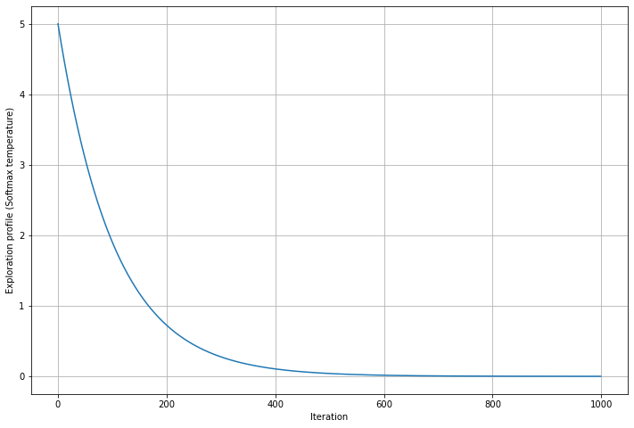

REACH 500 at: 720

#####################################

gamma = **0.98** # gamma parameter for the long term reward

replay_memory_capacity = 10000 # Replay memory capacity

lr = 1e-2 # Optimizer learning rate

target_net_update_steps = 10 # Number of episodes to wait before updating the target network

batch_size = 128 # Number of samples to take from the replay memory for each update

bad_state_penalty = 0 # Penalty to the reward when we are in a bad state (in this case when the pole falls down)

min_samples_for_training = 1000 # Minimum samples in the replay memory to enable the training

Exploration Profile:

initial_value = **7**

exp_decay = np.exp(-np.log(initial_value) / num_iterations * 6)

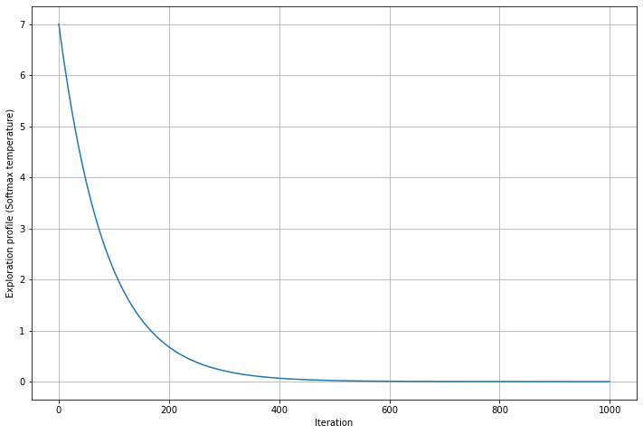

REACH 500 at: 700

################################

gamma = **0.98** # gamma parameter for the long term reward

replay_memory_capacity = 10000 # Replay memory capacity

lr = 1e-2 # Optimizer learning rate

target_net_update_steps = 10 # Number of episodes to wait before updating the target network

batch_size = 128 # Number of samples to take from the replay memory for each update

bad_state_penalty = 0 # Penalty to the reward when we are in a bad state (in this case when the pole falls down)

min_samples_for_training = 1000 # Minimum samples in the replay memory to enable the training

Exploration Profile:

* initial_value = **9**
* exp_decay = np.exp(-np.log(initial_value) / num_iterations * **10**)

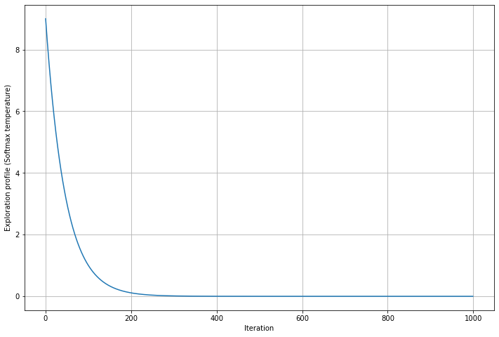

REACH 500 at: 590

##############################

gamma = **0.98** # gamma parameter for the long term reward

replay_memory_capacity = 10000 # Replay memory capacity

lr = **1e-3** # Optimizer learning rate

target_net_update_steps = 10 # Number of episodes to wait before updating the target network

batch_size = 128 # Number of samples to take from the replay memory for each update

bad_state_penalty = 0 # Penalty to the reward when we are in a bad state (in this case when the pole falls down)

min_samples_for_training = 1000 # Minimum samples in the replay memory to enable the training

Exploration Profile:

* initial_value = **9**
* exp_decay = np.exp(-np.log(initial_value) / num_iterations * **10**)



REACH 500 at: noooooooooooooooo

##############################

1. **Control CartPole using the screen pixels**

…..

To get the state in the previous approach we used: next_state, reward, done, info = env.step(action) but now we will ignore the next_state variable and use as state the 800x600x3 tensor returned by env.render(mode='rgb_array')

…

We just took the third channel of the RGB image, because the colors does not matter, then we cut it to make because there are parts of the screen that does not matter like all pixels after 325 are always white,… to make it compact, … rescale 4 time smaller

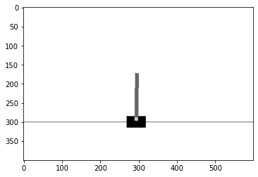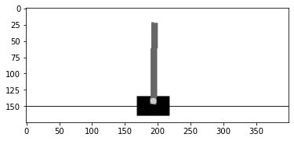

(172, 400)

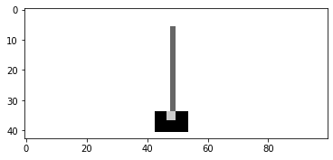

(43,100)

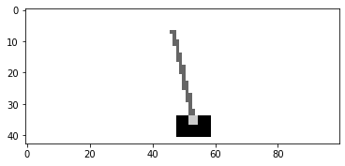

1. **MountainCar-v0 Gym Environment**

The ***MountainCar-v0* environment** consist of a car running on a hill, that can only choose to push left, push right or do nothing. The objective is to get the car to the top of the hill (top = 0.5 position).

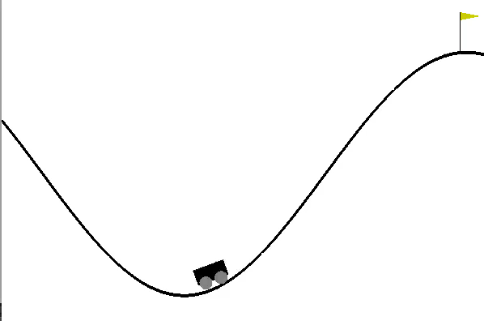

**State space vector:**

* 0: position
* 1: velocity

**Action space vector:**

* 0: push left
* 1: no push
* 2: push right

**Reward:** -1 for each time step, until the goal position of 0.5 is reached. There is no penalty for climbing the left hill, which upon reached acts as a wall.

BUT we decided to create our own reward function based on the position and direction (velocity) of the car, that is the following:

pos_weight = 6

if (action ==0 and state[1]<0) or (action==2 and state[1]>0):

reward= reward + pos_weight * np.abs(state[0]+0.5)

else: reward=reward-2

Basically, if the Car is pushing left and the velocity is negative (direction to the left) or the car is pushing right and the velocity is positive (direction to the right) we give a positive reward. Because we want that the car stays away as much possible from the center (we don’t want that the car remains stationary), otherwise we give a negative reward. (The specific values of the parameters were found after some fine tuning).

**Starting State:** Random position from -0.6 to -0.4 with no velocity.

**Episode Termination:** when you reach 0.5 position, or if 200 iterations are reached.

The training procedure is exactly the same used in the *CartPole-v1* environment except for the reward function, and the score that here we define as the final position of the car.